# The period and length of a pendulum

Name: Lathitha

Surname: Hobongwana

Student Number: 50863649

NPHY111

Group: 11

Aim:

This experiment aims to determine the acceleration due to gravity by investigating the relationship between the period and length of a pendulum.

Apparatus:

* Stand
* Ruler
* Thread
* Stopwatch
* Bob

Introduction and Theory:

In this experiment, the dependence of a simple pendulum’s period, T, on its length, L, is conformed and exploited to indirectly determine the acceleration due to gravity, g. The simple pendulum consists of a light string fixed at one end with a massive bob attached to the other end. Note that the period depends on the length of pendulum but not on the bob’s mass. This will be tested in the experiment by determining the period of the pendulum for two deferent masses but the same length. Giovanni Battista Riccioli is credited with performing the first accurate experiment on the acceleration due to gravity in 1651. His interest was to investigate 1 the claims of Galileo and not to determine the acceleration due to gravity, however. He used meticulously calibrated pendulums to time the free fall of bodies from deferent heights. As this experiment shows, g can be determined without using free falling bodies but just using the pendulum itself. Christian Huygens deduced (1), and in 1660 used it to arrive at the first accurate estimate of the acceleration due to gravity (9:81 m=s2 in SI units). The experiment calls for the measurement of ten cycles of the pendulum with a certain mass, mA, and length, L. This is repeated with a second mass, mB to investigate the periods mass independence. By measuring the time for ten cycles, one reduces the uncertainty in the calculated (single cycle) period. If the length is changed and the procedure repeated, the data can be used to plot the period squared, T 2 versus length, L.

Method:

We suspended the pendulum bob from the stand using a thread. We adjust the length of the pendulum to equal 1.0 m.

We displaced the bob through an angle and released it to oscillate 20 times. We determined the time for 20 oscillations, this was done three times to get three different time values.

We repeated this for the length of a string of 0.90m, 0.80m, 0.70m, 0.60m, 0.50m, and 0.40m.

Results:

|  |  |  |  |  |  |  |
| --- | --- | --- | --- | --- | --- | --- |
| $$l(m)$$ |  | $$t_{2}(s)$$ | $$t_{3}(s)$$ |  |  | $$T^{2}$$ |
| 1,0 |  |  |  |  |  |  |
| 0,9 |  |  |  |  |  |  |
| 0,8 |  |  |  |  |  |  |
| 0,7 |  |  |  |  |  |  |
| 0,6 |  |  |  |  |  |  |
| 0,5 |  |  |  |  |  |  |
| 0,4 |  |  |  |  |  |  |

Analysis:

Using MATLAB program, we plot a graph of restoring force vs displacement, and we compare the fitting function of the form:

$f\left(x\right)=mx+c$

We use the slope obtained from the fitting function (and error in the slope) to write down the spring constant.

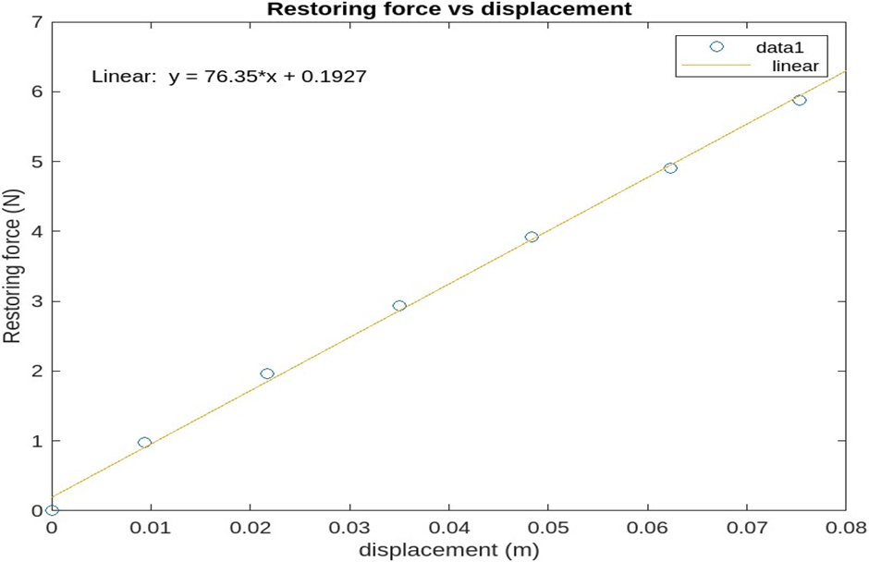

From the graph we get a slope with the value: 76.35

The slope represents the change in restoring force over change in displacement ($\frac{Δf}{Δd}$) which gives us the (negative) spring constant ($-k)$

Therefore, the value of the spring constant from the slope is:

$-k=76.35$

$⇒$ $k=-76.35$

We calculate the theoretical value of the spring constant using the last value of the restoring force and its corresponding displacement value from the data:

From the equation:

$f= -kx$

We get:

$f=5.88 N$

$x=0,0753 m$

Therefore:

$5.88=-$ k (0.0753)

$k=-\left(\frac{5.88}{0.0753}\right)$

$k=-78.09$

To get the percentage error we do the following calculation:

$\%error=\frac{(theoretical)k-(experimental)k}{(experimental)k}*100$

$=\frac{78,09-76,35}{78,09}*100$

$=2,23\% error$

Conclusion:

Judging from the graph and the low percentage error conclude that the data is nicely or accurately described by the equation; $f= -kx$. However, there are some discrepancies which are the result of human error during the experiment these include not having measured the accurate displacement and not having accurately followed the procedure.

The value of the spring constant from the graph is :76.35

Whilst the value of the theoretical spring constant is:78,09

The error in slope or spring constant is:0,653

Reference:

MATLAB program:

d = [ 0.0 0.0093 0.0217 0.0350 0.0483 0.0623 0.0753];

r = [0.0 0.98 1.96 2.94 3.92 4.90 5.88];

n = length(d);

sumd =0.0;

sumr =0.0;

sumdr =0.0;

sumdd =0.0;

for i = 1:n

sumd = sumd + d(i);

sumr = sumr + r(i);

sumdr = sumdr + d(i)*r(i);

sumdd = sumdd + d(i)*d(i);

end

slope = (n*sumdr - sumd*sumr)/(n*sumdd - sumd*sumd);

y_intercept = (sumdd*sumr - sumd*sumdr)/(n*sumdd - sumd*sumd);

z =slope*d + y_intercept;

plot(d,r,'o');

xlabel('Displacement (m)');

ylabel('Restoring force (N)');

title(“Restoring force vs Displacement”);

% Errors

di = r -(slope*d + y_intercept);

Error_in_slope =sqrt(sum(di.*di)/(n-2))/(sqrt(n*sumdd - sumd*sumd));

Error_in_y_intercept = sqrt(sum(di.*di)*sumdd/(n*sumdd - sumd*sumd))/(sqrt(n*sumdd - sumd*sumd));

% write code to determine the acceleration and its uncertainty and the velocity

% Calculate acceleration

spring_constant = -1 * slope;

% Display results

disp("spring_constant:" + spring_constant);

disp("Error in slope: " + Error_in_slope);